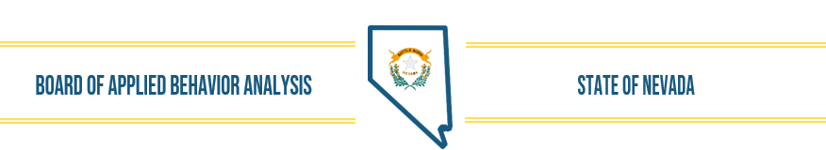
NOTICE OF PUBLIC MEETING
Applied Behavior Analysis BOARD MEETING

Date of Posting: August 10, 2022
Date and Time of Meeting: August 16, 2022, 10:00 AM

Name of Organization: Nevada Applied Behavior Analysis Board

Place of Meeting: Teleconference and NV ABA Office-
6170 Mae Anne Ave. #1 Reno, NV

Please place your phone or your computer microphone on mute unless providing public comment.
Join Zoom Meeting
https://us06web.zoom.us/j/87312111937?pwd=Sk5ZcnY4ek0rNUNsZ016endSNWNJZz09
Meeting ID: 873 1211 1937
Passcode: 183177
One tap mobile
+17207072699,,87312111937#,,,,*183177# US (Denver)
+12532158782,,87312111937#,,,,*183177# US (Tacoma)
Dial by your location
+1 253 215 8782 US (Tacoma)
+1 346 248 7799 US (Houston)
Meeting ID: 873 1211 1937
Passcode: 183177
Find your local number: https://us06web.zoom.us/u/kbssp6BJkB

Please Note: The Applied Behavior Analysis Board (ABAB) may (1) address agenda items out of sequence to accommodate persons appearing before the Board or to aid the efficiency or effectiveness of the meeting; (2) combine items for consideration by the public body; and (3) pull or remove items from the agenda at any time. The Board may convene in closed session to consider the character, alleged misconduct, professional competence or physical or mental health of a person. See NRS 241.030. Prior to the commencement and conclusion of a contested case or a quasi-judicial proceeding that may affect the due process rights of an individual the board may refuse to consider public comment. See NRS 233B.126. At the discretion of the Chair, public comment is welcomed by the Board, but will be limited to three (3) minutes per person. A public comment time will be available at the beginning of the meeting and then once again prior to adjournment of the meeting. The Chair may allow additional time to be given a speaker as time allows and in his/her sole discretion. Once all items on the agenda are completed the meeting will adjourn.

Nevada Applied Behavior Analysis Board Board Meeting Agenda August 16, 2022

- Call to Order, Roll Call of Members, and Establish Quorum

- Public Comment
(No action may be taken upon a matter raised under public comment period unless the matter itself has been specifically included on an agenda as an item. Comments will be limited to three minutes per person. Persons making comment will be asked to begin by stating their name for the record and to spell their last name and provide the secretary with written comments.)

- Approval of July 19, 2022 Board Meeting Minutes (For Possible Action)

- Executive Director’s Report (For Possible Action)

- Review, Discussion, and Possible Approval of Board Activities (For Possible Action)
  - Website update/discussion
  - Listserv update/discussion
  - Supervisory requirements including: responsibility of notification of changes, disciplinary action/process, BACB coordination; public registry

- Financial Update (For Possible Action)
- July Financial Information
- 2022-23 Budget

- Complaint Status Update

- Discussion of Current Status of Applications and other Licensing Activities
(For Possible Action)
        - Jurisprudence Exam
        - Licenses/Registrations issued

- Determine Future Agenda Items (For Possible Action)

- Public Comment
(No action may be taken upon a matter raised under public comment period unless the matter itself has been specifically included on an agenda as an action item. Comments will be limited to three minutes per person. Persons making comment will be asked to begin by stating their name for the record and to spell their last name and provide the secretary with written comments.)

- Adjournment

NOTE: We are pleased to make reasonable accommodations for members of the public who have disabilities and wish to attend the meeting. If special arrangements for the meeting are necessary, please notify Wendy Knorr at (775-746-9429) as soon as possible and at least one business day in advance of the meeting. If you wish, you may e-mail her at executivedirector@nvababoard.org. Supporting materials for this meeting are available at 6170 MaeAnne Ave., Suite 1, Reno, NV 89523 or by contacting Wendy Knorr at 775-746-9429, or by email executivedirector@nvababoard.org. Agenda and supporting materials posted at these locations and online on the following sites: https://notice.nv.gov/ www.nvababoard.org and NVABA Office

