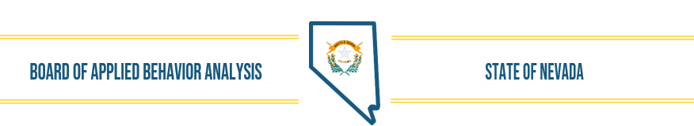
Nevada Applied Behavior Analysis Board
DRAFT Board Meeting Minutes- November 29, 2022
- Call to Order, Roll Call of Members, and Establish Quorum
The meeting was called to order by Christy Fuller 10: 01 a.m.
Members in attendance: Christy Fuller, Courtney LoMonaco, and Rachel Gwin,
DAG Counsel, Henna Rasul and ED, Wendy Knorr
Drs. Leytham and Fronapfel were not in attendance.

- Public Comment - No public comment

- Approval of October 2022 Board Meeting Minutes
Motion to approve minutes as presented by Courtney LoMonaco; Seconded by Rachel Gwin; motion passed.

- Executive Director’s Report
Wendy Knorr provided information on FARB conference in January. Approval was given in a previous meeting for Wendy’s attendance. Board recommended approving for three board members to attend in addition if their schedules would allow. Interested Board members need to contact Wendy and she will assist in making reservations. Motion to pay for up to three Board members to attend was made by Courtney LoMonaco, seconded by Rachel Gwin, motion carried.

- Review, Discussion, and Possible Approval of Board Activities
  - Annual Evaluation process- After the discussion at the last meeting, reviewing current and previous evaluation tools and job descriptions, a tool was developed and presented for discussion and approval. The tool is based on the tool used by the Psychology Board as it most closely matched the current job description, etc. A draft was sent to the Board members for review and suggestions with the intent of approving a tool to be used for the ED evaluation. After discussion, the board members agreed that there would not be a community/consumer portion to this evaluation process, but that a separate evaluation would be developed in the future that would assist the Board in developing/determining direction for the board and setting priorities. It was decided that it will be a separate effort and will be discussed in greater detail at a future meeting. The ED evaluation will be just that, an evaluation of the ED by the Board members. Wendy will provide a self-evaluation as well. Courtney LoMonaco will coordinate the evaluation process and lead the review at the next meeting. Board members were asked to return their completed reviews to Courtney by end of day, Dec. 7, 2022. She will compile the information and prepare to present it at the next meeting. Clarification was provided by DAG Rasul about the content of the evaluation presented during the meeting and the Open Meeting Law and public information requirements.
Courtney LoMonaco made the motion to approve the evaluation tool; use an electronic version of it; and have responses returned to her by Dec. 7. Rachel Gwin seconded the motion; motion passed.

  - Board position vacancies, process, update- Dr. Fronapfel and Christy Fuller have been reappointed to the NV ABA Board for another 4-year term. An individual has been appointed by the Governor’s Office to complete the remaining 2 years of Dr. Leytham’s term upon his resignation Dec. 31, 2022. The announcement of the new board member will be made once confirmation of their acceptance is confirmed. Applicants for the Community Member position are still being sought.

- Financial Update
- October Financial Information was available.

- Discussion of Current Status of Applications and other Licensing Activities
- Licenses/Registrations issued:
RBTs: 62 issued in October 50 so far in Nov. Total 2103
Renewals completed: 531 as of meeting date
LBAs 12 issued in October 8 so far in Nov . Total 544
Renewals completed: 70 as of meeting date
Christy Fuller asked about proration of fees for new RBT’s registered in Oct/Nov/Dec. Wendy confirmed that $70 fee is what is being expected. Certemy had a built-in proration schedule but anyone paying the $3,6,9 additional fee based on information provided in Certemy will be refunded the additional fee.
Wendy confirmed that an inactive license request form was not originally provided and is being developed for individuals requesting their license be placed on ‘inactive’ status as provided in NRS.

- Determine Future Agenda Items-
Christy Fuller made the motion to include standing items and Executive Director’s evaluation for the Dec. 13 meeting. Rachel Gwin seconded the motion; motion passed.

- Public Comment – No public comment
- Adjournment- The meeting was adjourned at 11:15 a.m. by Christy Fuller

