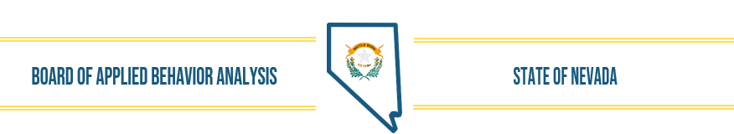
Nevada Applied Behavior Analysis Board ABA Board Meeting DRAFT Minutes October 6, 2023

- The meeting was called to order by Dr. Fronapfel at 9 a.m. Members in attendance were: Dr. Fronapfel, Christy Fuller, Lynda Tasche and Stephanie Huff. Courtney LoMonaco was absent. Wendy Knorr, Executive Director and Henna Rasul, DAG/Counsel were also in attendance.

- Public Comment- None presented at this time.

- Approval of September 19, 2023, Board Meeting Minutes – Christy Fuller made the motion to approved the meeting minutes as presented; Stephanie Huff seconded the motion and the motion passed.

- Review, Discussion, and Possible Approval of Board Activities
Wendy Knorr presented the opportunity for the NV ABA board to be represented at the NABA professional conference Oct. 13-15. Christy Fuller reached out to NABA about our participation and they offered a free table for our use. Information to share would include the Board’s Mission Statement, Licensee/Registrant information, upcoming LiveScan implementation, new CE requirements and plans for NAC review/revision. It was also suggested that a comment/survey opportunity be offered to gather feedback and suggestions.
Henna confirmed that information that is or would be presented on the website would be appropriate to present in this forum. Christy Fuller made the motion that the Board participate in the NABA professional conference with a poster, handouts and other information to represent information about the Board and it’s activities to the professional community. Stephanie Huff seconded the motion and the motion passed.
- Public Comment – None presented at this time.

- The meeting was adjourned by Brighid at 9:11 a.m.

