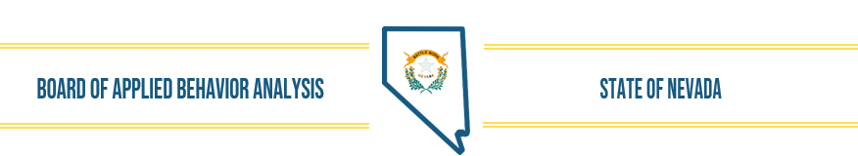
Mission Statement: Upholding ethical standards of practice and conduct, the Nevada Board of Applied Behavior Analysis licenses and registers trained professionals, prioritizing consumer protection through regulatory oversight.
January 21, 2025, Board Meeting- DRAFT MINUTES
- The meeting was called to order by Dr. Fronapfel at 10:00 a.m. Members present: Dr. Fronapfel, Christy Fuller and Stephanie Huff. Lynda Tache was absent. DAG, Henna Rasul and Executive Director were also present.

- Mission Statement was read aloud by Dr. Fronapfel.

- There was no public comment.

- Christy Fuller made the motion to approve the December 17, 2024 meeting minutes, as presented. Stephanie Huff seconded the motion, and the motion passed.

- Executive Director, Wendy Knorr reported:

Renewals ended 12.31.24. This year, a late renewal period is available through 2.28.25, and a number of applicants are taking advantage of it. In addition, the Inactive status was made available for those applicants between jobs, without supervisors, etc., basically allowing for a short pause. The registry notes the inactive status. Initially it looks like approximately 1,000 or so individuals did not renew – the majority being RBT’s. More detailed information will be available once the late renewal period is closed and we have time to review the data.

The Collaborative met to review and discuss SB78. It was briefly mentioned in the Governor’s state of the state address. Boards and licensees are slowly being made aware of the proposed legislation and the potential impact. At this point the collaborative is unsure how the boards will respond. It appears that B&I is proposing some amendments to the initial organizational structure, impacting the composition of the merged boards. Adjustments to the original plan have not been made public but several boards have been notified of the possible changes.

The Fiscal Note Process has been changed. During each Legislative session, boards are typically asked for data about the potential financial impact of proposed legislation and take it into consideration as part of the process. Last session NVABA responded to approximately 20 requests. We were initially notified that we would be involved again in the process and were offered training by LCB. Shortly before the training date we were de-invited by LCB and informed that B&I would be coordinating the process for the identified boards “under their purview.” The timeline is very short for these requests typically, and now with the addition of another layer of involvement (B&I) it will be even tighter. WK contacted LCB to express concerns about the process and was told this was unusual (hadn’t seen this in his 20+ yr. career) but it was the direction he was told to go. I reached out to both the Governor’s finance director and B&I and have not heard back from either. WK said that she personally believes this is an overreach of authority by B&I and that the boards will effectively lose their voice during this process. The legislative session begins Feb.3 through June 2.

Fees decreased for Background Clearance- The federal government’s portion of the fees collected for background clearance processing decreased by $1.25. The total fee is now $39.00 vs 40.25. The applications and website have been updated to reflect the change.

- No new BDR’s have been identified at this time. Wendy asked to be notified if anyone hears of any potential legislation impacting ABA in the state to assist in monitoring it during the upcoming legislative session. Information about all the legislation under consideration is available and updated on the legislative website.

- During the first board meeting each year, elections are held to name the President/Chair and Sec/Treasurer for the year. Stephanie Huff has been reappointed to the board for a four-year term. Courtney LoMonaco’s term ended last month, and a new member will be appointed within the next month or so by the Governor. Christy Fuller nominated Dr. Fronapfel as President; Stephanie Huff seconded the motion, and it passed. Christy Fuller nominated Stephanie Huff as Secretary/Treasurer; Dr. Fronapfel seconded the motion, and it passed.

Last meeting, the board authorized Christy Fuller to complete the final edit of a board statement requested by Medicaid. Christy provided the final version which was submitted to Medicaid the end of December for their future meetings.
- Complaints- Two new complaints were received for a total of 40 currently open/active.

- New/Renewal Applications
Renewals December January to date Total
RBT- 1965 73 56 2133 (down 1100)
LaBA 28 0 1 29
LBA 594 7 14 615 (down 21)

- Agenda items for next meeting: Christy Fuller made the motion to include all the standing agenda items and add NABA report; Stephanie Huff seconded the motion and it passed.

- There was no Public Comment.

- Dr. Fronapfel adjourned the meeting at 10:27 a.m.

